Datalogging For M40/M30

Version: Jason wang/052923

# Pin connection

|  |  |
| --- | --- |
| Pin | Function |
| 25 | Power up or off |
|  | Left button |
|  |  |
|  |  |
|  |  |

# Start-up screen

The screen will display PID Analyzers Logo for 2 seconds.

# Run Screen

Display gas

# Menu – Gas selection

# Menu – Range selection

Change of range will not change the calibration.

# Menu – Alarm selection

# Data Logging

## Datalogging data format

Here is the data output in the serial monitor:

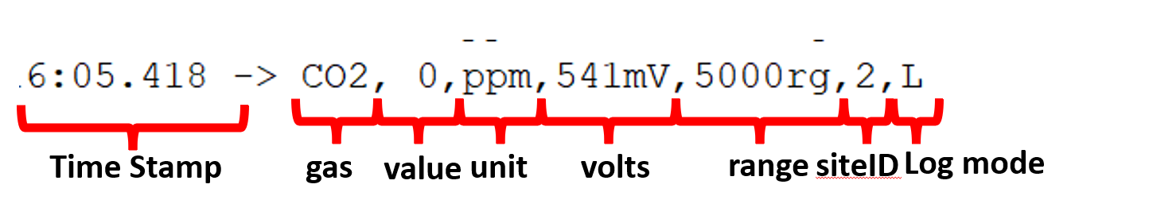

## Datalogging mode

Use left button to select among three datalogging mode in the main screen: none, L(continuous logging), or P(logging when S button is hitted):

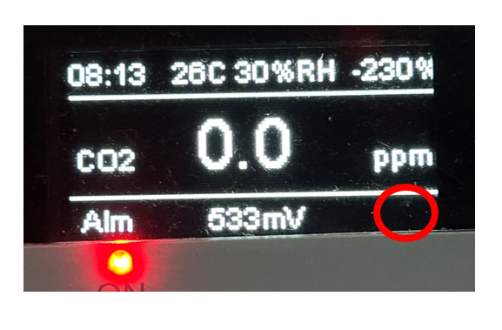

Figure . none logging

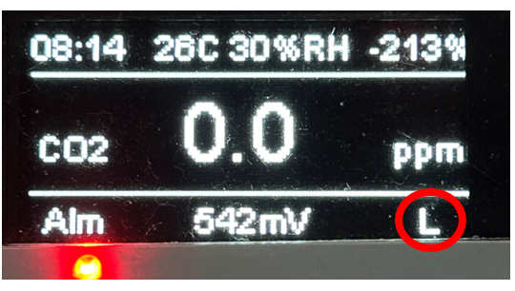

Figure . L (continuous logging)

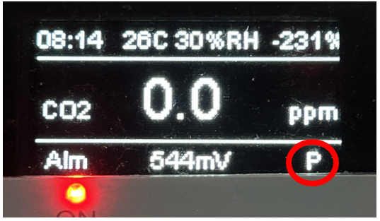

Figure . P (logging with button)

## Site ID setting

In the menu, user can define Site ID, from 1 to 20, which will be included in the data output.

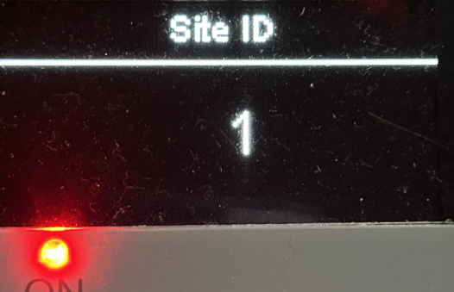

Figure . Site ID setting

## Datalogging duration

User can define the datalogging duration for continuous among options from 1 minute to non-stop.

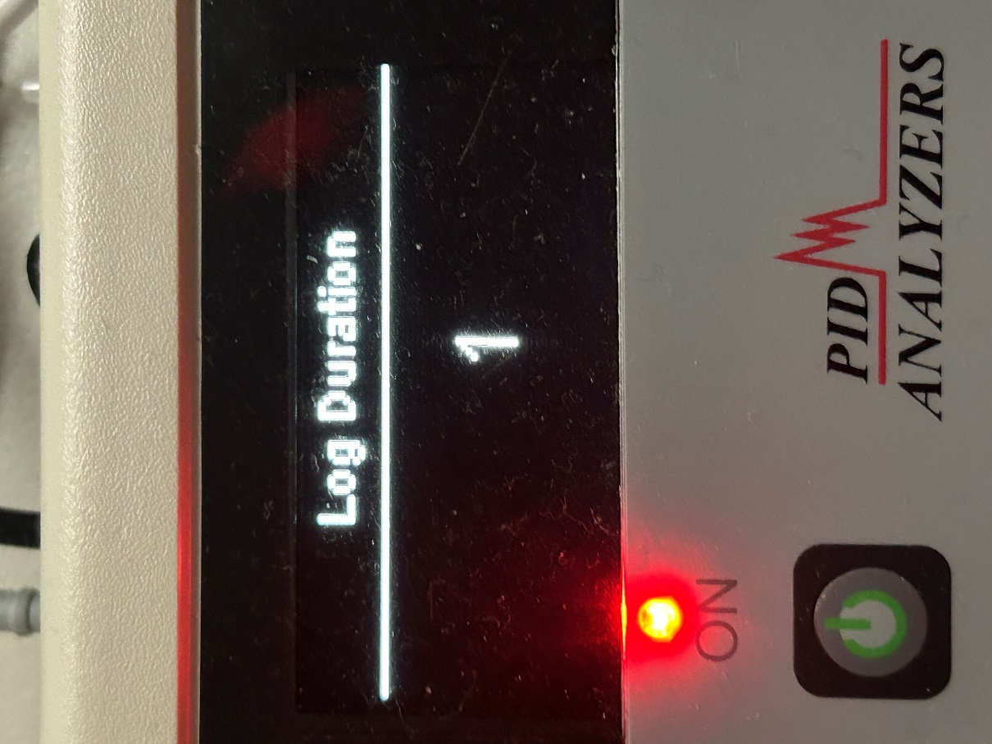

Figure . Logging Duration Setting